**LEACH in NetSim**

**Software Recommended:** NetSim Standard v10.2 (64-bit), Visual Studio 2015

**Low-energy adaptive clustering hierarchy ("LEACH")**is a [MAC](https://en.wikipedia.org/wiki/Media_access_control) protocol which is integrated with clustering and a simple routing protocol in [wireless sensor networks](https://en.wikipedia.org/wiki/Wireless_sensor_network) (WSNs). The goal of LEACH is to lower the energy consumption required to create and maintain clusters in order to improve the life time of a wireless sensor network.

This Cross Layer Protocol is implemented in NetSim in MAC layer which involves ZigBee Protocol and Network layer which involves DSR protocol. The clustering of sensors happens in the Network layer and the Cluster head election involves interacting with the MAC layer to obtain the remaining power of the sensors.

A **LEACH.c** file is added to the DSR project.

1. For this implementation of LEACH, the number of Clusters is fixed as 4 and all the 4 clusters are equal. If the user wants to change it, then he/she must also change the static routing for the Cluster Heads and the ClusterElement array accordingly.
2. To make 4 equal clusters the number of sensors must be 4,16,36,64,100. Depending on the number of sensors, the ClusterElements array must be defined. Here, it has been defined and commented for 4,16,36,64,100 sensors. Uncomment the one you want to use.

The file contains the following funcitons:

fn_NetSim_LEACH_CheckDestination()

This function is used to check whether the current device is the destination (i.e) the sinknode or not. Else the packet will be forwarded to the next hop.

fn_NetSim_LEACH_GetNextHop()

This function is used to identify the next hop in cases where the current device is either a sensor within the cluster or the cluster head. Static routes are defined in this function. It returns the Device id of the next hop.

fn_NetSim_LEACH_AssignClusterHead ()

This function is used to dynamically assign cluster heads within a cluster based on the residual energy. The sensor with higher remaining power in comparison to other sensors within the same cluster will be elected as the cluster head.

fn_NetSim_LEACH_IdentifyCluster()

This function is used to determine the cluster to which a sensor belongs. It returns the cluster id of the cluster.

# Steps:

1. Open the Code folder from LEACH_V10.1 folder and double click on the NetSim.sln file to open the project in visual studio 2015.
2. Right click on Solution ‘NetSim’ (2 projects) displayed on top of the Solution Explorer and select rebuild.

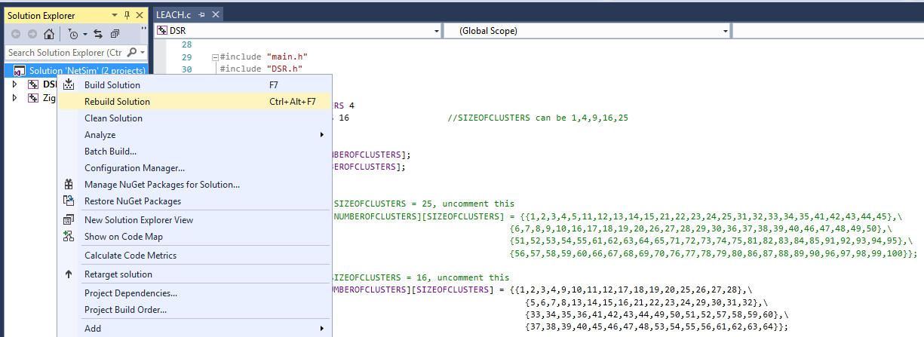

1. Now copy the DLL’s – libDSR.dll and libZigBee.dll from the DLL folder inside the LEACH.
2. Replace these DLL’s in NetSim bin folder in the NetSim installation directory (**C:\Program Files\NetSim Standard\bin**) after renaming the original libDSR.dll and libZigBee.dll files.

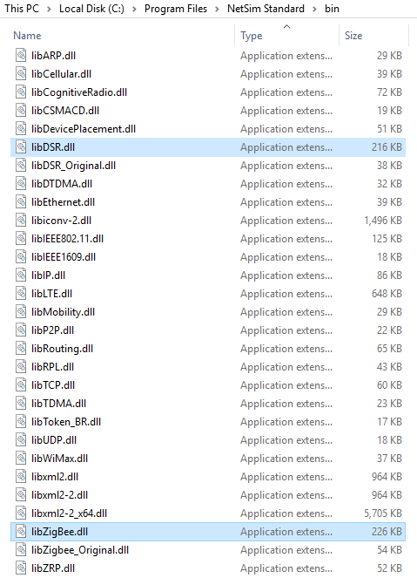

1. Now create a Network Scenario in NetSim WSN Network as per the Number of clusters and size of clusters that are set in the LEACH code. By default the code runs for a scenario with 64 sensors uniformly placed, with the SINKNODE placed as per the screenshot below.

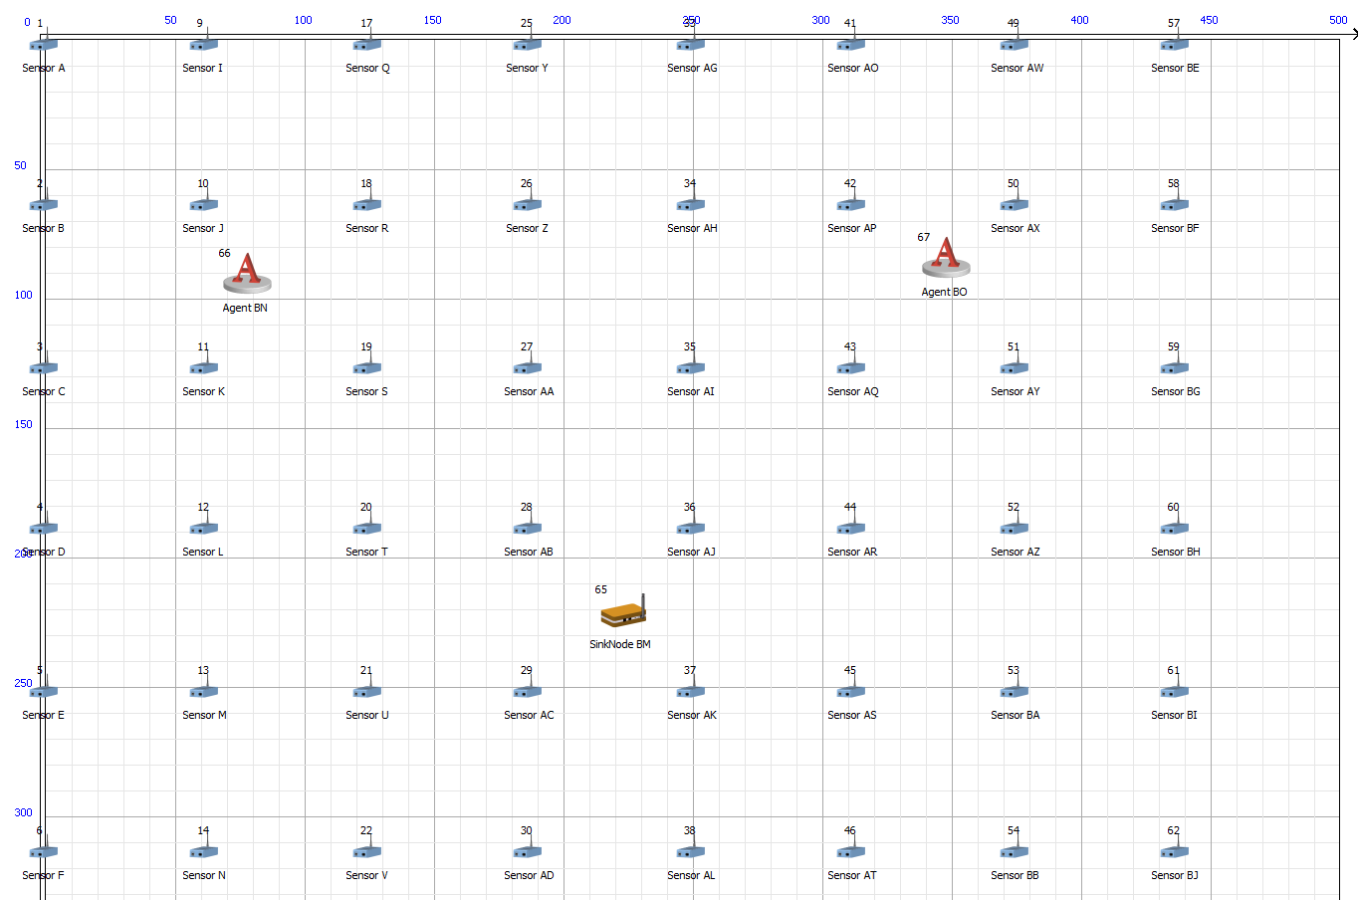

1. Run the simulation.
2. View the packet animation. You will note that the sensors directly start transmitting packets without route establishment since the routes are statically defined in LEACH. You will also note that the cluster heads keep changing dynamically.